PROJECT(DBMS)

DAIRY MANAGEMENT

SYSTEM

Review-1

Group Members:-

A.REVANTH - AM.EN.U4CSE22102

B.DARSHAN - AM.EN.U4CSE22114

K.CHARAN - AM.EN.U4CSE22131

P.MOULI - AM.EN.U4CSE22140

ER-Diagram:-

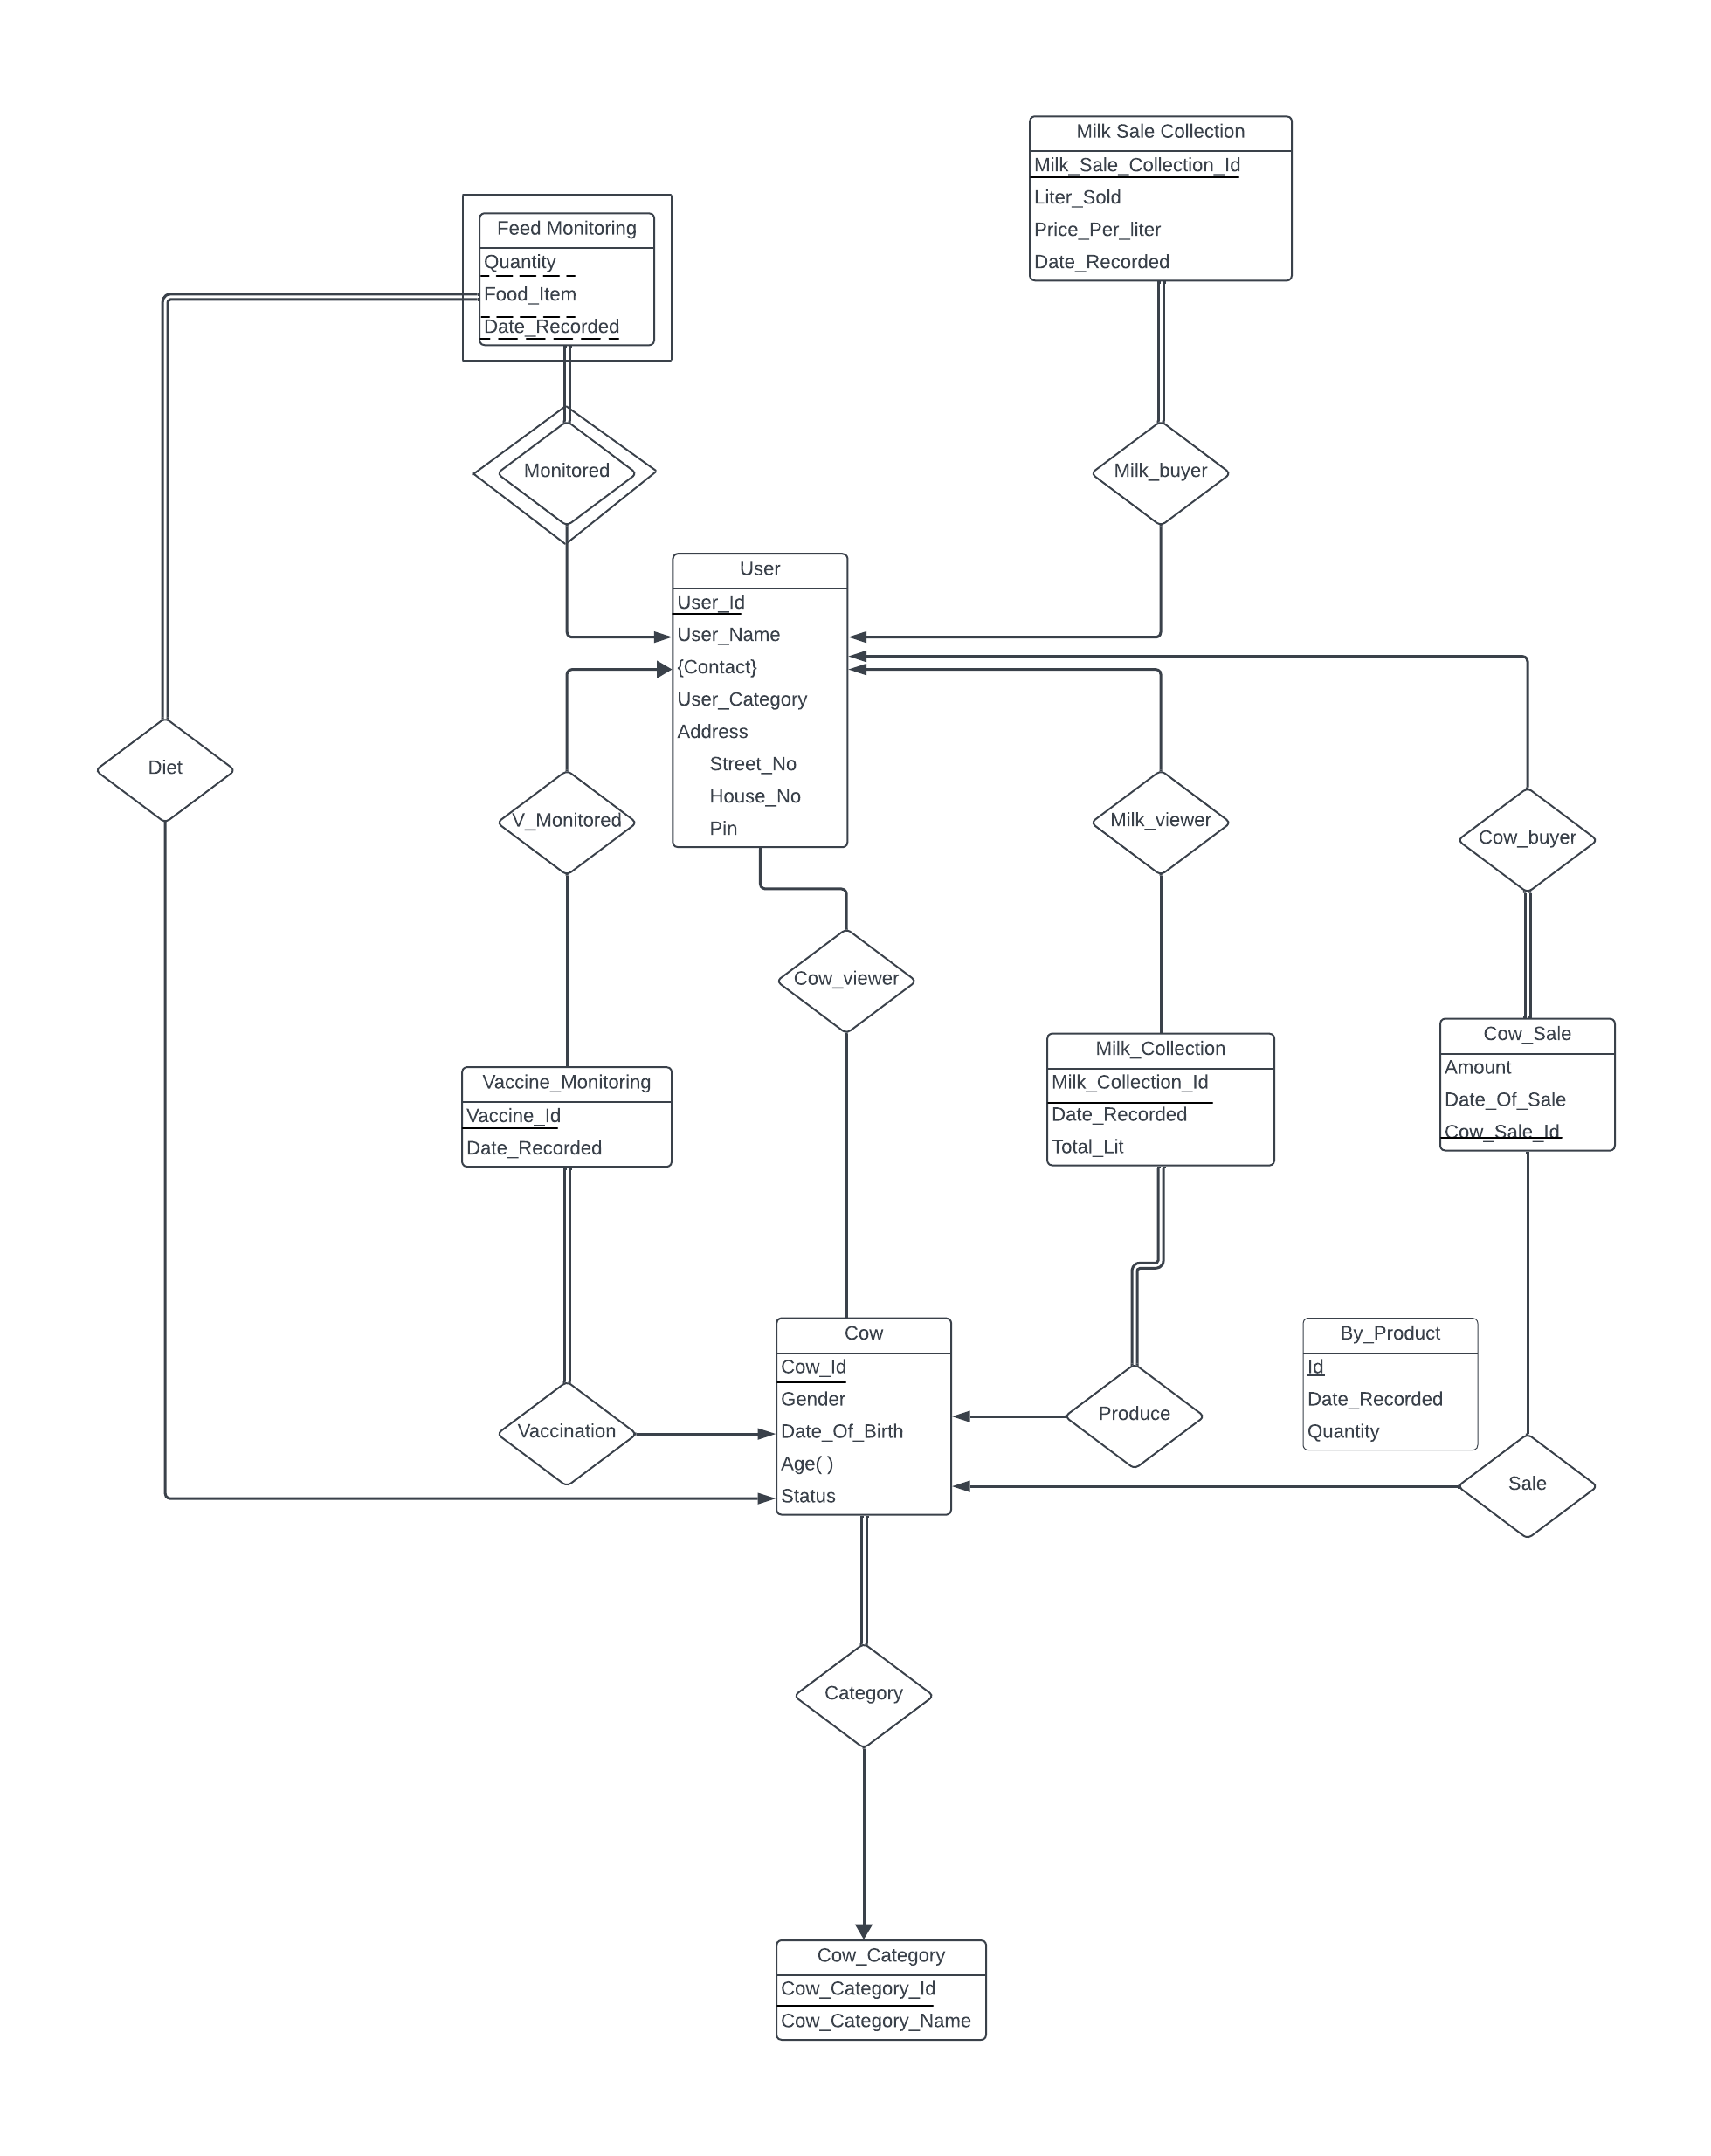

Schema Diagram:-

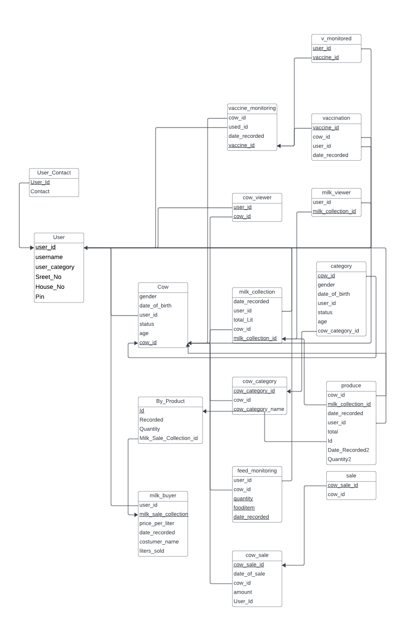

Relational Schema:-

• User(User_Id , User_Name, User_Category, Street_No, House_No, Pin)

• User_Contact(User_Id, Contact)

• Cow(Cow_Id, Gender, Date_Of_Birth, Status)

• Cow_viewer(user_id,cow_id)

• Milk_buyer(user_id,Produce_Id,milk_sale_collection,litres_sold,price_per_litre,date_recorded)

• Vaccine_Monitoring(Vaccine_Id,Date_Recorded)

• V_Monitored(V_Result,User_Id,Vaccine_Id,User_Name,User_Category,Street_No,House_No,

Pin)

• Milk_Viewer(User_Id,Milk_Collection_Id)

• Milk_Collection(Milk_Collection_Id,Date_Recorded,Total_Lit)

• Vaccination(Vaccine_Id,Cow_Id,Date_Recorded)

• Cow_Sale(Cow_Sale_Id,Date_Of_Sale,Amount)

• Sale(Cow_Sale_Id,Cow_Id)

• Produce_Milk_Collection(Cow_id,Produce_Id,Date_Recorded,Quantity,Milk_Collection_Id,D ate_Recorded,Total_Lit)

• Cow_Category(Cow_Category_Id,Cow_Category_Name)

• Category(Cow_Id,Gender,Date_Of_Birth,Status,Cow_Category_Id)

• Feed_Monitoring(Cow_Id,User_Id,Quantity,Food_Item,Date_Recorded)

* By_Product(Id,Date_Recorded2,Quantity2)
* Ternary relation-Produce,Milk_Buyer
* Multi Valued Attribute-Contact
* Derived Attribute-Age
* Composite Attribute-Address